RKE2 and Rancher

Runbook

Table of Contents

1 Install RKE2 and Rancher 5

1.1 On First Control Plane Node: 5

1.1.1 Populate config.yaml (Optional: See Note) 5

1.1.2 Install RKE2 5

1.1.3 Link kubectl and copy rke2.yaml to ~/.kube/ 5

1.2 On Secondary Control Plane Nodes 6

1.2.1 Populate config.yaml 6

1.2.2 Install RKE2 6

1.2.3 Link kubectl and copy rke2.yaml to ~/.kube/ 6

1.3 On Node with kubectl access (can be a cluster node or remote node) 6

1.3.1 Verify Status of Cluster 6

1.3.2 Install Helm 6

1.3.3 Install Helm Repos 7

1.3.4 Install cert-manager CRD 7

1.3.5 Install cert-manager 7

1.3.6 Install Rancher 7

1.4 Monitor Status of Rancher Deployment 7

1.5 Log locations and other files of interest found on the RKE2 control-plane nodes 7

2 Rancher Upgrade 8

2.1 Backup Rancher 8

2.1.1 Take a Rancher Backup via the Rancher Backup Operator. 8

2.2 Verify availability of helm repository 8

2.3 Update helm repository 8

2.4 Retrieve Helm Options 8

2.5 Upgrade Rancher 9

2.5.1 Run the upgrade helm command. 9

2.5.2 Monitor the new deployment. 9

3 Upgrade RKE2 10

3.1 Upgrade Rancher Management Server RKE2 Version 10

3.1.1 Navigate to Cluster Management 10

3.1.2 From the Clusters Menu 10

3.1.3 Select the version of RKE2 from the pull down and click Save 10

3.2 Upgrade Downstream Cluster RKE2 Version 11

3.2.1 Navigate to Cluster Management 11

3.2.2 From the Clusters Menu 11

3.2.3 Select the version of RKE2 from the pull down and click Save 11

4 Downstream Cluster Build 12

4.1 Custom Cluster Registration from GUI 12

4.1.1 Navigate to Cluster Management 12

4.1.2 From the Clusters Menu Click Create 12

4.1.3 From Cluster Create Menu Click Custom 12

4.1.4 Create Cluster 13

4.1.5 The resulting page once the Cluster resource is created 13

4.2 Custom Cluster Registration from API calls 14

4.2.1 Creating Cluster through Rancher CLI or by API call documentation 14

4.2.2 Example for getting custom cluster registration command: 14

4.2.3 Get Cluster ID (returns rancher generated clusterid c-m-shw7c57m) 14

4.2.4 Get Cluster Registration Curl Commands 14

4.2.5 Example Output: 15

5 Longhorn Backup To MINIO 17

5.1 Longhorn MINIO Setup 17

5.1.1 Create Minio Bucket 17

5.1.2 Create Access Key and Secret Key 17

5.1.3 In Minio settings 17

5.1.4 Recorded Information So Far 17

5.1.5 Encode information for use in creating secret 17

5.1.6 Create Secret longhorn-minio-credential.yaml 17

5.1.7 Apply secret 17

5.1.8 Configure Longhorn for Backups 18

6 Harbor Installation via HELM 19

6.1 Install Harbor from Rancher Partner Charts 19

6.1.1 Create Namespace for Harbor Installation 19

6.1.2 From Rancher UI Navigate to Apps 🡪 Charts 19

6.1.3 Click Install 20

6.1.4 Enter namespace and deployment name for harbor and click Next 21

6.2 Modify Harber Values 21

6.2.1 Customize helm values for installation. 22

6.2.2 Consider changing passwords 22

6.2.3 Update Node Selectors 23

6.2.4 Other lines of interest 23

6.2.5 See Appendix A for example values file 23

6.3 Perform Install 24

6.3.1 Click Install once all edits have been made to the values 24

7 Neuvector Installation 25

7.1 Create the neuvector project 25

7.2 Install Nuevector from Cluster Tools 25

8 Rolling Restart Procedure 26

8.1 Restart Rancher Management Cluster 26

8.1.1 Control-Plane 26

8.2 Restart Downstream Cluster 26

8.2.1 Control-Plane 26

8.2.2 Worker 26

9 Shutdown and Startup 27

9.1 Shutdown 27

9.1.1 Shutdown Worker Nodes 27

9.1.2 Shutdown ControlPlane Nodes One At A Time 27

9.2 Startup 27

9.2.1 Startup ControlPlane Nodes One At A Time 27

9.2.2 Startup Worker Nodes 27

10 Rancher App Charts 28

10.1 Rancher provided Helm Charts 28

10.2 Recommended Tools 28

APPENDIX A – Harbor Values 29

Appendix B - Logging Configs 40

ClusterFlow (Active – Cluster scope) 40

ClusterOutput (Active – Cluster Scope) 40

Flow (Example – Namespace Scope) 41

Output (Example – Namespace Scope) 41

Appendix C – Training and References 42

Rancher Documentation 42

RKE2 Documentation 42

Neuvector Documentation 42

Suse Events 42

Neuvector Youtube 42

Longhorn Documentation 42

Rancher Github 42

RKE2 Github 43

Neuvector Github 43

Longhorn Github 43

CIS Self Assessment 43

Rancher Academy 43

# Install RKE2 and Rancher

Verify /var/lib/rancher space on all nodes. Recommended 100GB – 200GB.

## On First Control Plane Node:

### Populate config.yaml (Optional: See Note)

mkdir -p /etc/rancher/rke2/

vi /etc/rancher/rke2/config.yaml

token: my-shared-secret

tls-san:

  - rancher.mycompany.com

RKE2 will create a config.yaml file on the first node if one does not exist.

A token will be assigned and stored in /var/lib/rancher/rke2/server/token

The process above allows for the token to be predefined

The example “my-shared-token” will be used by the other nodes to join the cluster

This token is interpreted literally, so it can have a plain text value or be a base64 encoded string

### Install RKE2

curl -sfL https://get.rke2.io | INSTALL_RKE2_TYPE=server sh -

systemctl enable rke2-server.service

systemctl start rke2-server.service

### Link kubectl and copy rke2.yaml to ~/.kube/

ln -s /var/lib/rancher/rke2/bin/kubectl /usr/local/bin/kubectl

cd

mkdir .kube

ln -s /etc/rancher/rke2/rke2.yaml .kube/config

chmod 600 .kube/config

## On Secondary Control Plane Nodes

### Populate config.yaml

mkdir -p /etc/rancher/rke2/

vi /etc/rancher/rke2/config.yaml

token: my-shared-secret

server: https://192.18.21.156:9345

tls-san:

  - rancher.mycompany.com

If not using a prepopulated token like “my-shared-secret”, use the token found in /var/lib/rancher/rke2/server/token from the Primary node.

### Install RKE2

curl -sfL https://get.rke2.io | INSTALL_RKE2_TYPE=server sh -

systemctl enable rke2-server.service

systemctl start rke2-server.service

### Link kubectl and copy rke2.yaml to ~/.kube/

ln -s /var/lib/rancher/rke2/bin/kubectl /usr/local/bin/kubectl

cd

mkdir .kube

ln -s /etc/rancher/rke2/rke2.yaml .kube/config

chmod 600 .kube/config

## On Node with kubectl access (can be a cluster node or remote node)

### Verify Status of Cluster

kubectl get nodes

[root@rancher01 ~]# kubectl get nodes

NAME         STATUS   ROLES                       AGE   VERSION

rancher01   Ready    control-plane,etcd,master   88m   v1.25.10+rke2r1

rancher02   Ready    control-plane,etcd,master   80m   v1.25.10+rke2r1

rancher03   Ready    control-plane,etcd,master   80m   v1.25.10+rke2r1

### Install Helm

curl -fsSL -o get_helm.sh https://raw.githubusercontent.com/helm/helm/main/scripts/get-helm-3

chmod 700 get_helm.sh

./get_helm.sh

### Install Helm Repos

helm repo add rancher-prime <https://charts.rancher.com/server-charts/prime>

helm repo add jetstack https://charts.jetstack.io

### Install cert-manager CRD

Verify latest release of cert manager at <https://github.com/cert-manager/cert-manager>

kubectl apply -f https://github.com/jetstack/cert-manager/releases/download/v1.16.2/cert-manager.crds.yaml

### Install cert-manager

helm install cert-manager jetstack/cert-manager --namespace cert-manager --create-namespace --version v1.16.2

### Install Rancher

helm install rancher rancher-prime/rancher --create-namespace --namespace cattle-system --set hostname=rancher.mycompany.com --set bootstrapPassword=rancher --set global.cattle.psp.enabled=false

## Monitor Status of Rancher Deployment

kubectl get pods -n cattle-system

[root@rancher01 ~]# kubectl get pods -n cattle-system

NAME                               READY   STATUS      RESTARTS   AGE

helm-operation-gxgbn               0/2     Completed   0          32m

rancher-75b4c59769-jvwt4           1/1     Running     0          79m

rancher-75b4c59769-kznbx           1/1     Running     0          79m

rancher-75b4c59769-mrfhk           1/1     Running     0          79m

rancher-webhook-64666d6db6-nfq7t   1/1     Running     0          76m

You should see 3 rancher pods, 1 rancher-webhook pod, and possibly some transient helm-operation pods used by the system to install the components of rancher from the helm chart.

## Log locations and other files of interest found on the RKE2 control-plane nodes

/var/lib/rancher/rke2/agent/logs/

/var/lib/rancher/rke2/agent/containerd/containerd.log

/var/lib/rancher/rke2/server/db/etcd/member/snap  #location of automatic etcd DB snapshots

/var/lib/rancher/rke2/server/token  #file containing the token used by other nodes to join the cluster (as seen in config.yaml)

/var/lib/rancher/rke2/server/manifests/  #location to place manifests for auto deployment to the cluster

# Rancher Upgrade

## Backup Rancher

**** Add section for Airgap considerations ****

### Take a Rancher Backup via the Rancher Backup Operator.

Install Rancher Backup Operator through UI

or

Install Rancher Backup Operator through command-line

ref Section 1: https://ranchermanager.docs.rancher.com/how-to-guides/new-user-guides/backup-restore-and-disaster-recovery/migrate-rancher-to-new-cluster#1-install-the-rancher-backup-helm-chart

## Verify availability of helm repository

    helm repo list

## Update helm repository

    helm repo update

## Retrieve Helm Options

Make sure you save the --set options you used during the initial install. You will need to use the

same options when you upgrade Rancher to new versions with Helm.

    helm -n cattle-system get values rancher

    helm -n cattle-system get values rancher > values.yaml

Edit the values.yaml and remove the bootstrapPassword line to preserve the admin password if it was changed after initial installation

Save values.yaml to some kind of source control (git) as an artifact for your system builds if not already done.

## Upgrade Rancher

### Run the upgrade helm command.

helm upgrade rancher rancher-prime/rancher --namespace cattle-system  --set hostname=rancher.company.com  --set otheroptions=value --set global.cattle.psp.enabled=false --version v2.7.6

or

    helm upgrade rancher rancher-prime/rancher --namespace cattle-system --version v2.7.6 -f values.yaml

### Monitor the new deployment.

    kubectl get pods -n cattle-system -w

Once all the new rancher pods and rancher-webhook pod are in a Ready state, log into the UI

and verify the appropriate Rancher version is showing in the "about" dashboard.

https://rancher.mycompany.com/dashboard/about

You will also find the most up to date versions of the Rancher CLI on the "about" page for download.

# Upgrade RKE2

## Upgrade Rancher Management Server RKE2 Version

### Navigate to Cluster Management

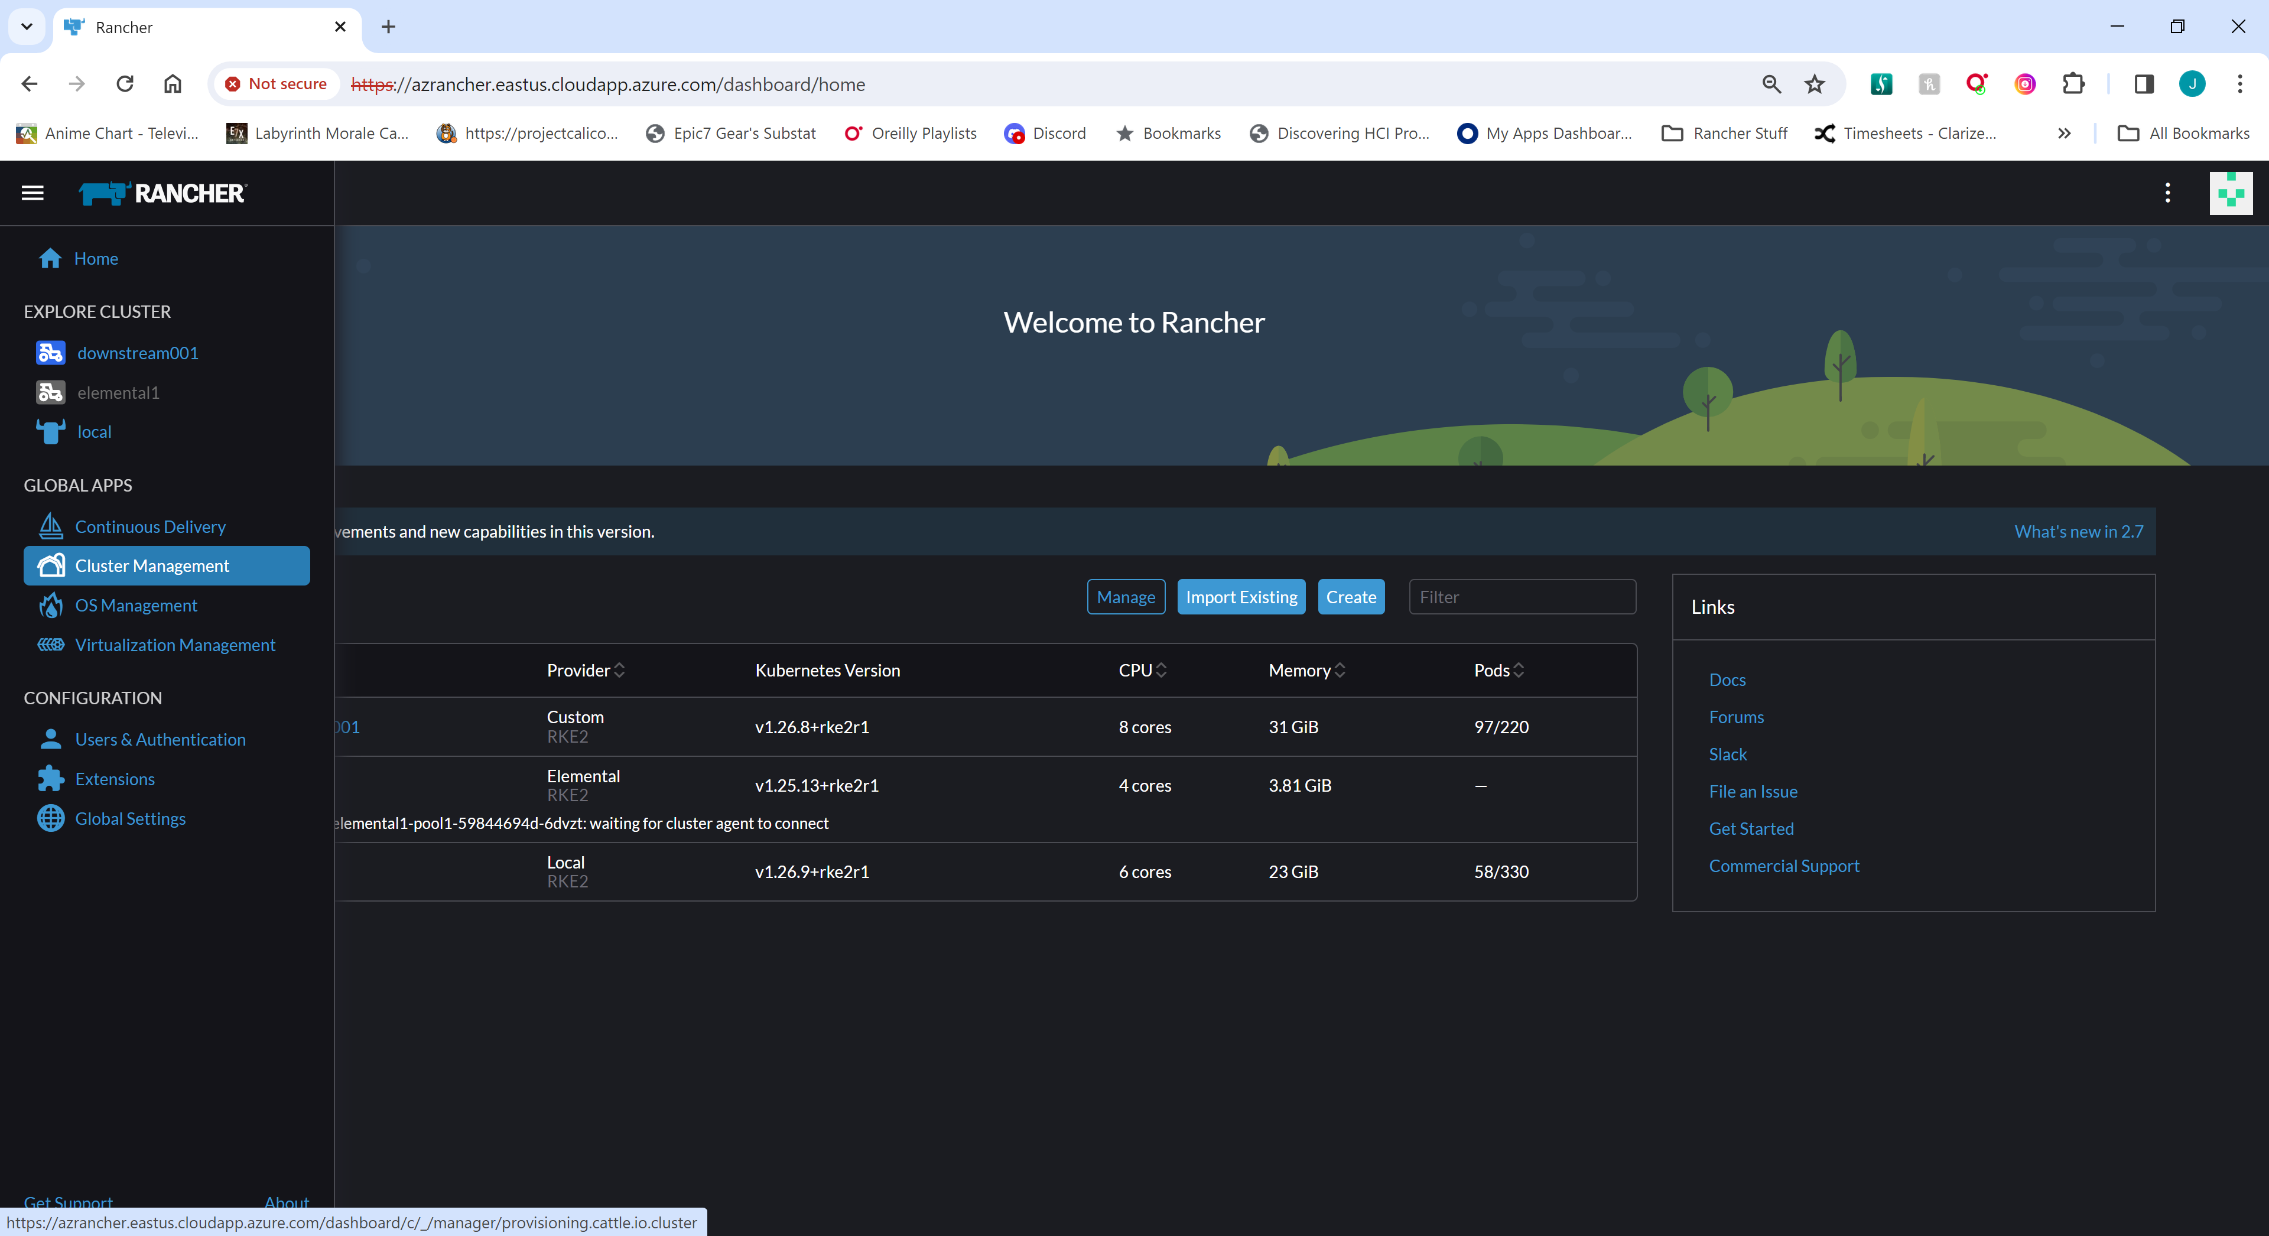

### From the Clusters Menu

Edit Config for the local cluster

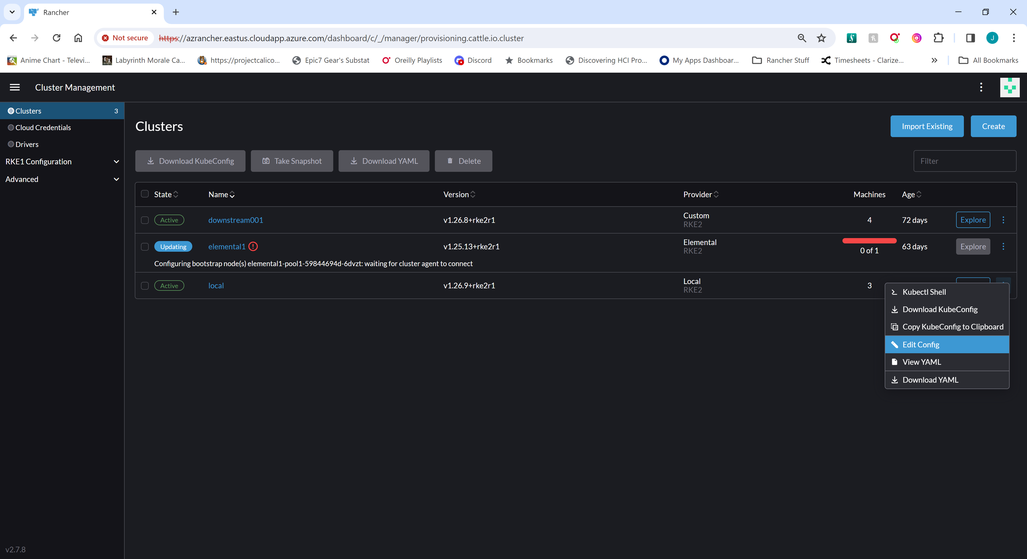

****ADD SECTION FOR CLUSTER OWNER ****

### Select the version of RKE2 from the pull down and click Save

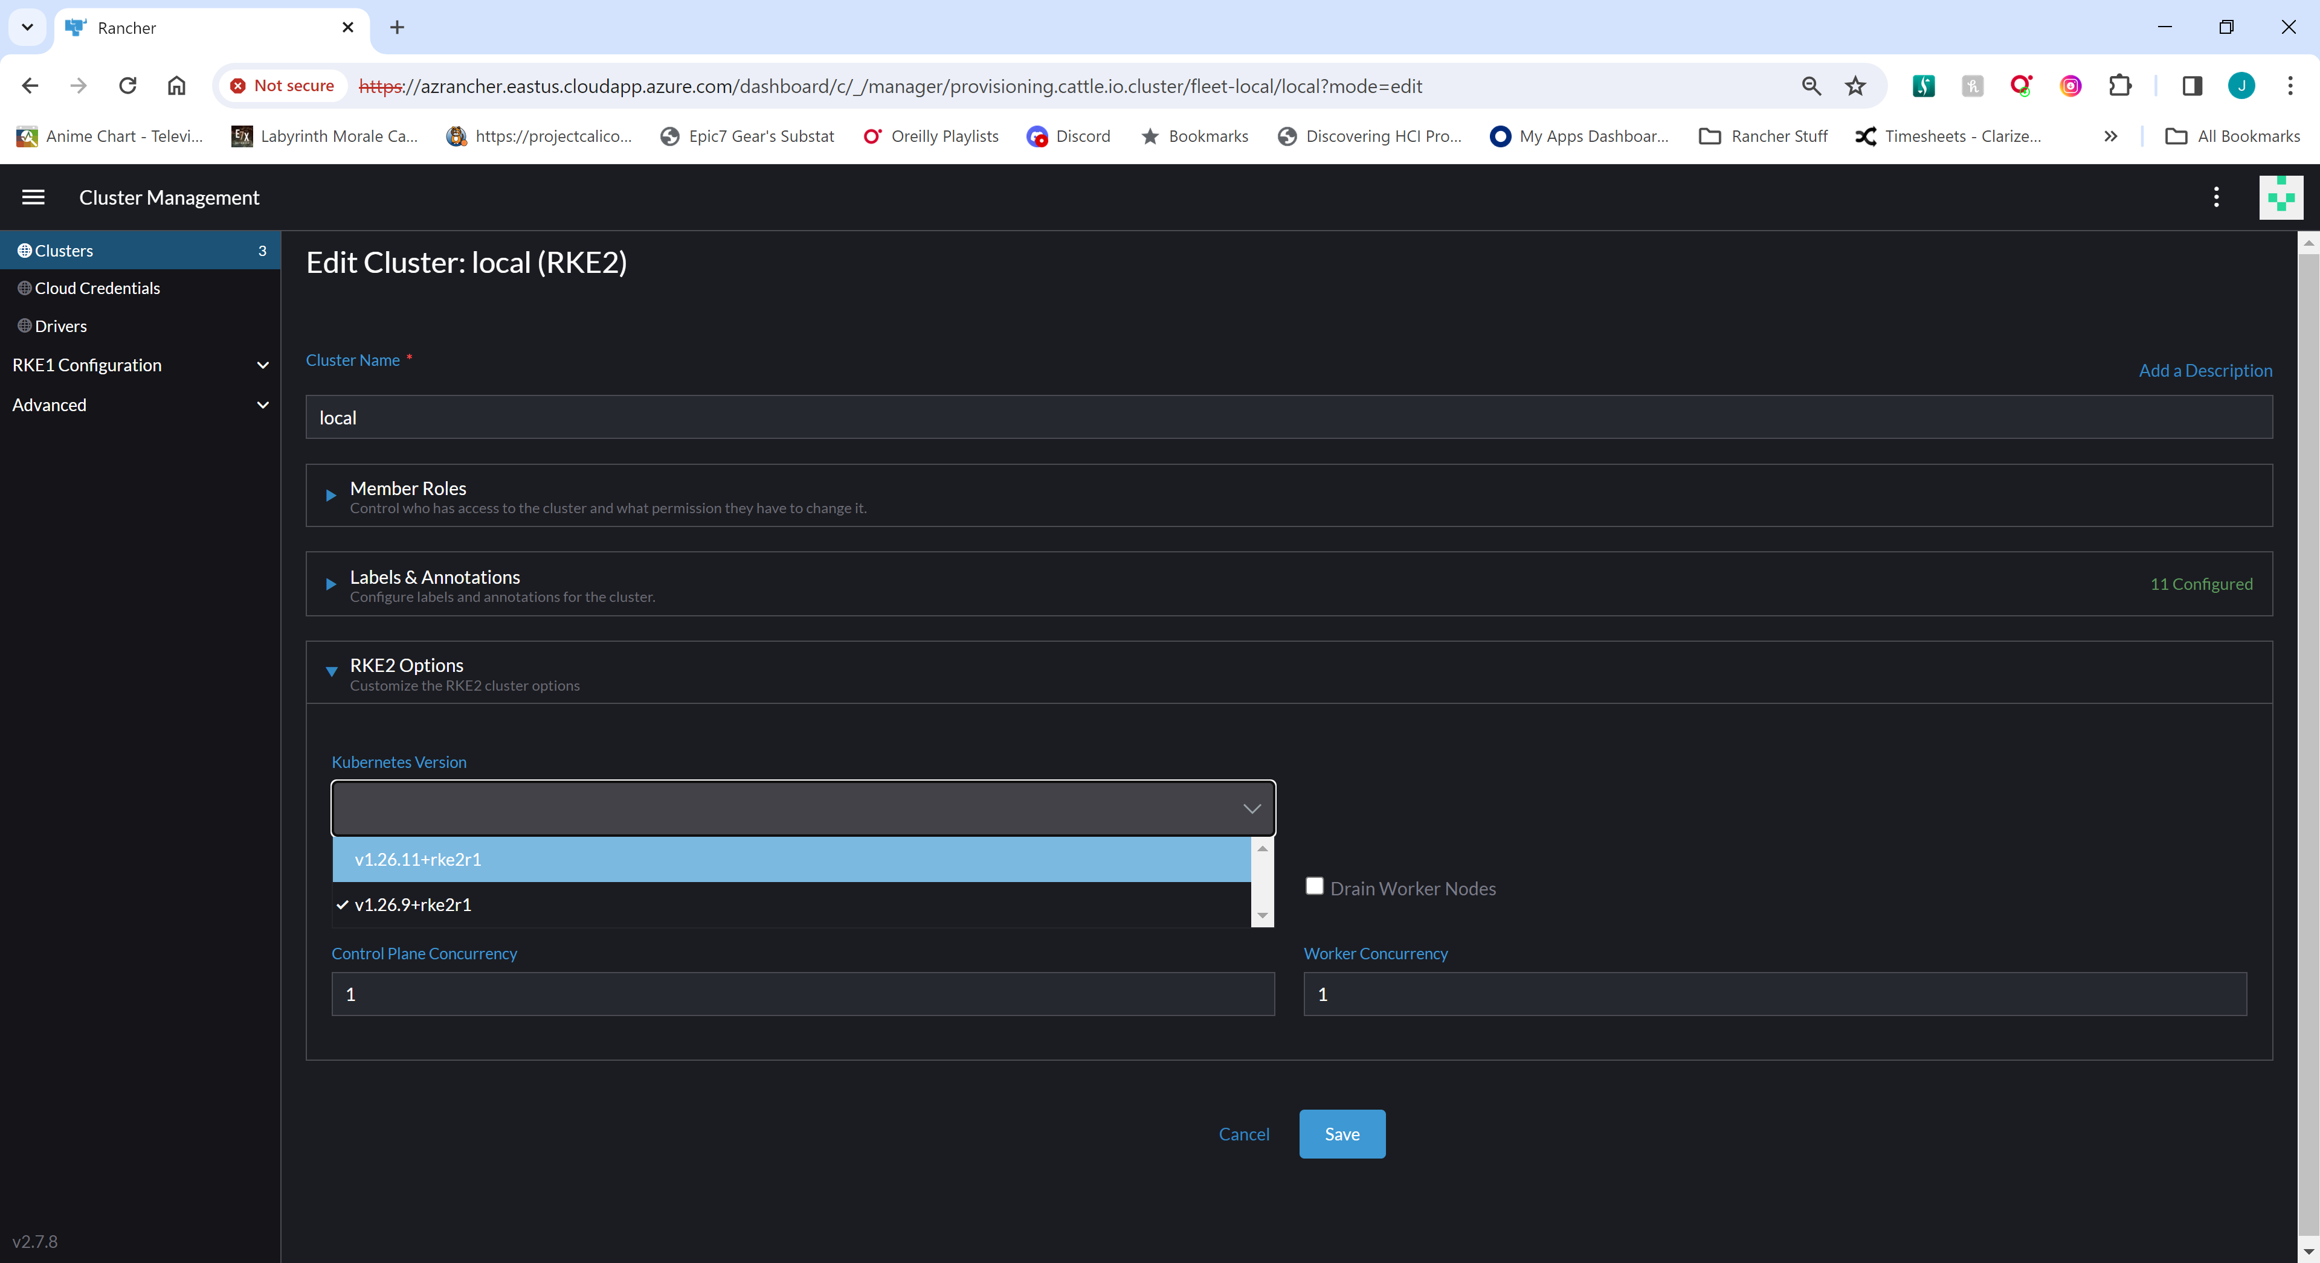

## Upgrade Downstream Cluster RKE2 Version

### Navigate to Cluster Management



### From the Clusters Menu

Edit Config for the downstream cluster

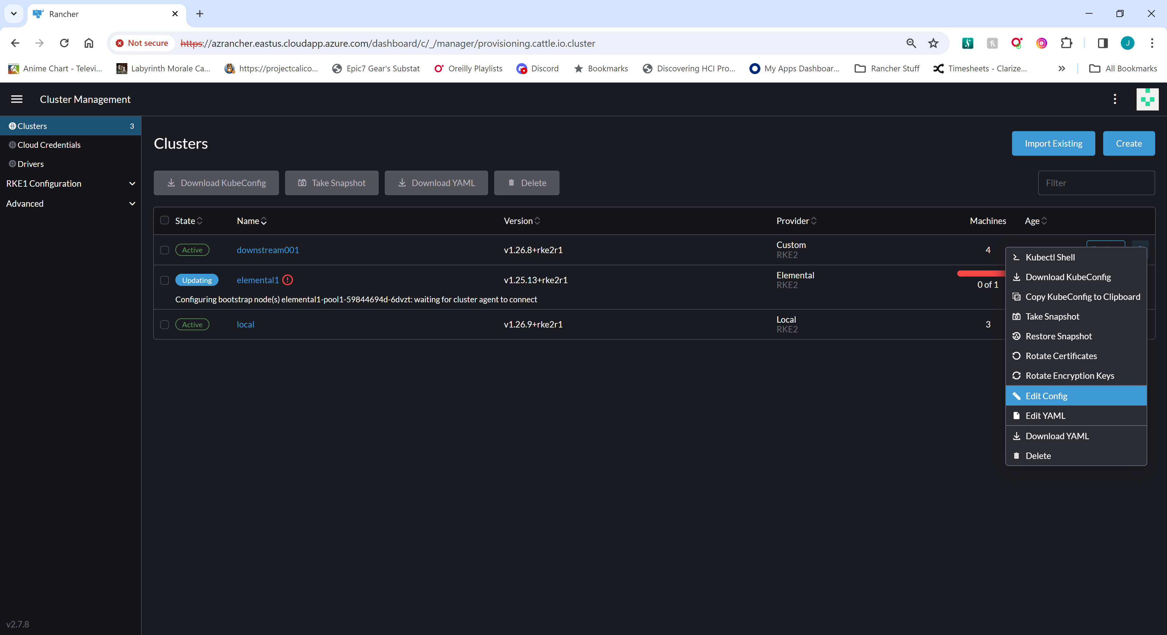

### Select the version of RKE2 from the pull down and click Save

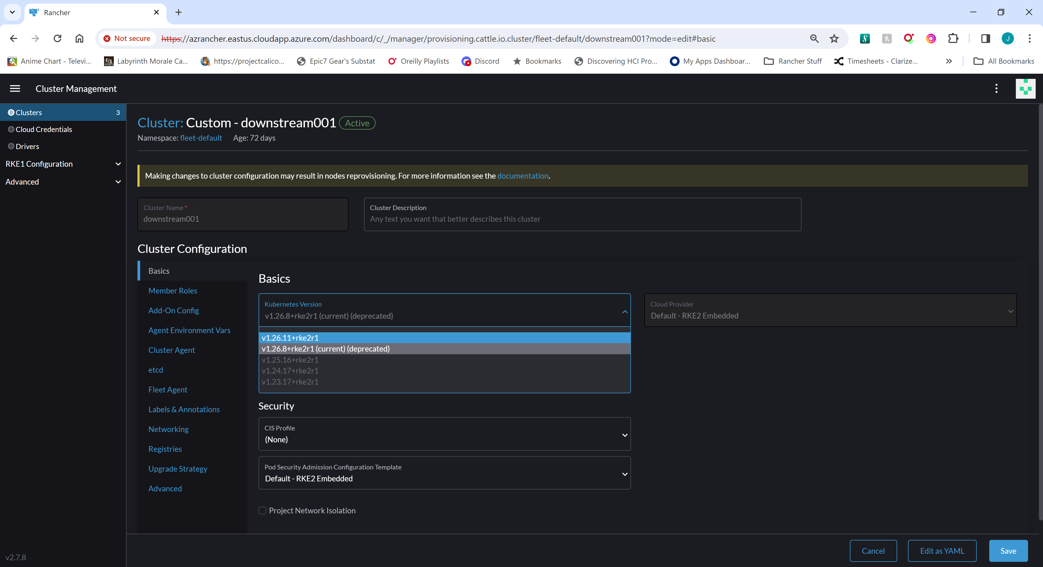

**** ADD SECTION FOR RKE2 STANDALONE CLUSTER UPGRADES AIRGAP and NORMAL ****

# Downstream Cluster Build

## Custom Cluster Registration from GUI

### Navigate to Cluster Management



### From the Clusters Menu Click Create

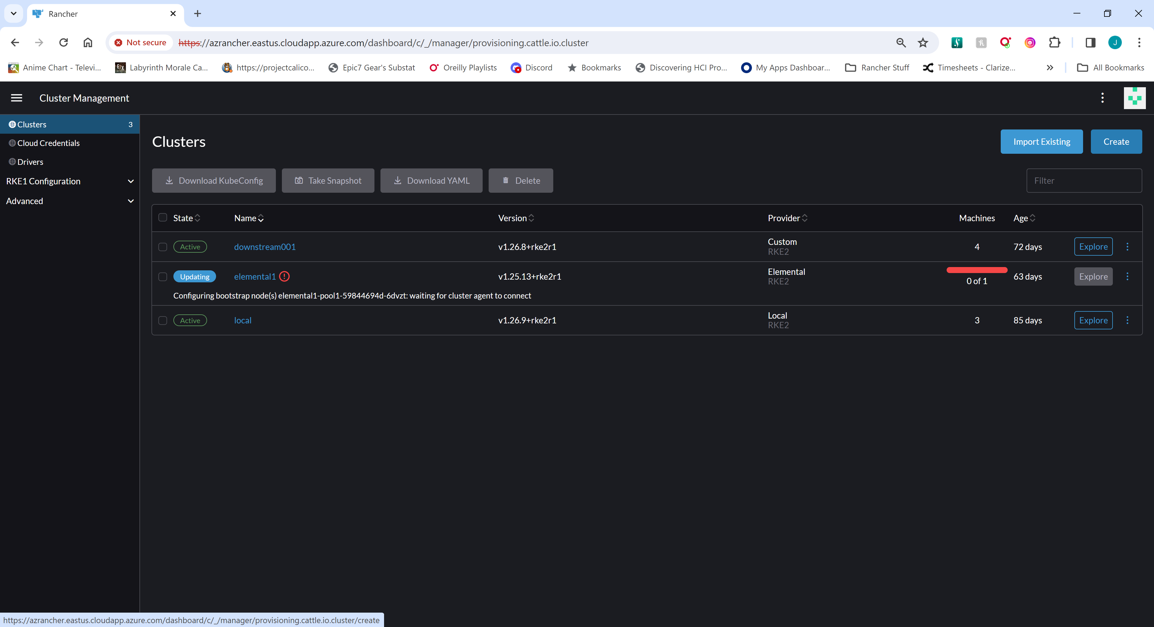

### From Cluster Create Menu Click Custom

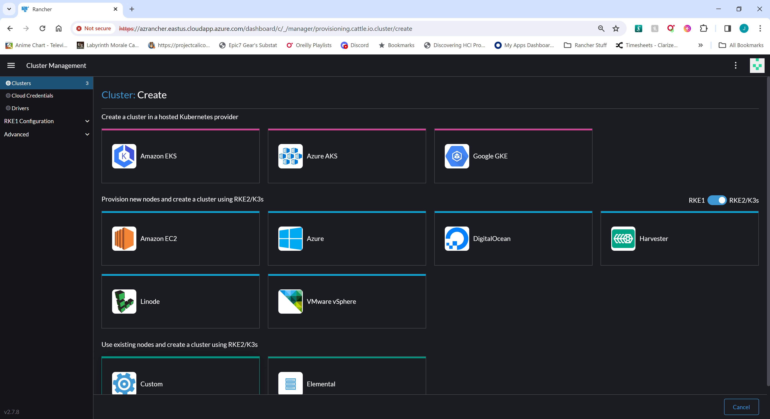

### Create Cluster

Provide a Cluster Name, desired RKE2 version, and any other customized information

Click Create

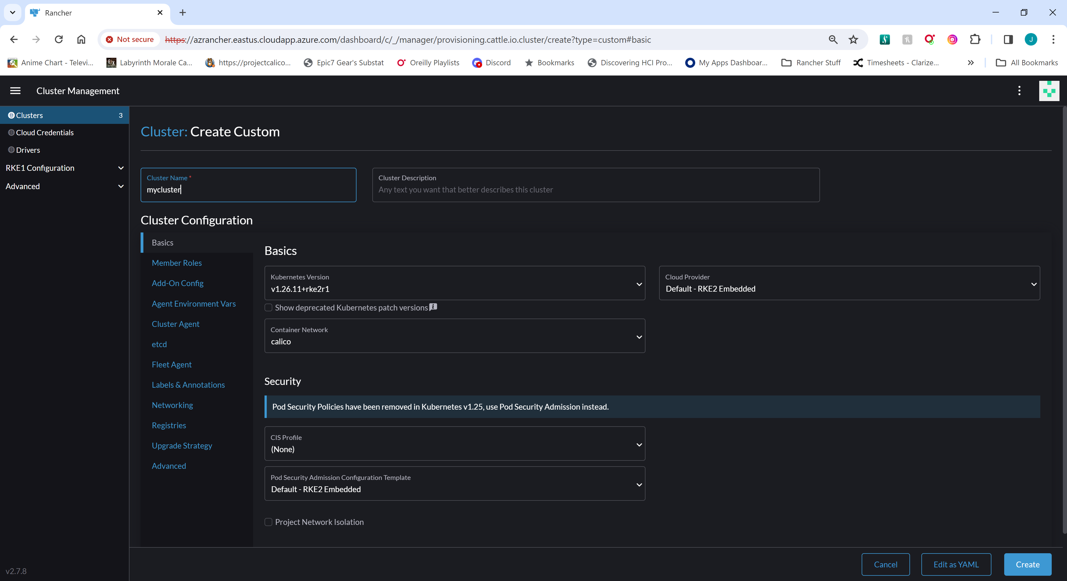

### The resulting page once the Cluster resource is created

Check the box next to “Insecure” if you need to skip TLS verification

Check or Uncheck the appropriate boxes for cluster roles to generate commands for each type of node. Windows Powershell commands will not populate until there is at least one LINUX based Controlplane/etcd node joined to the newly created cluster.

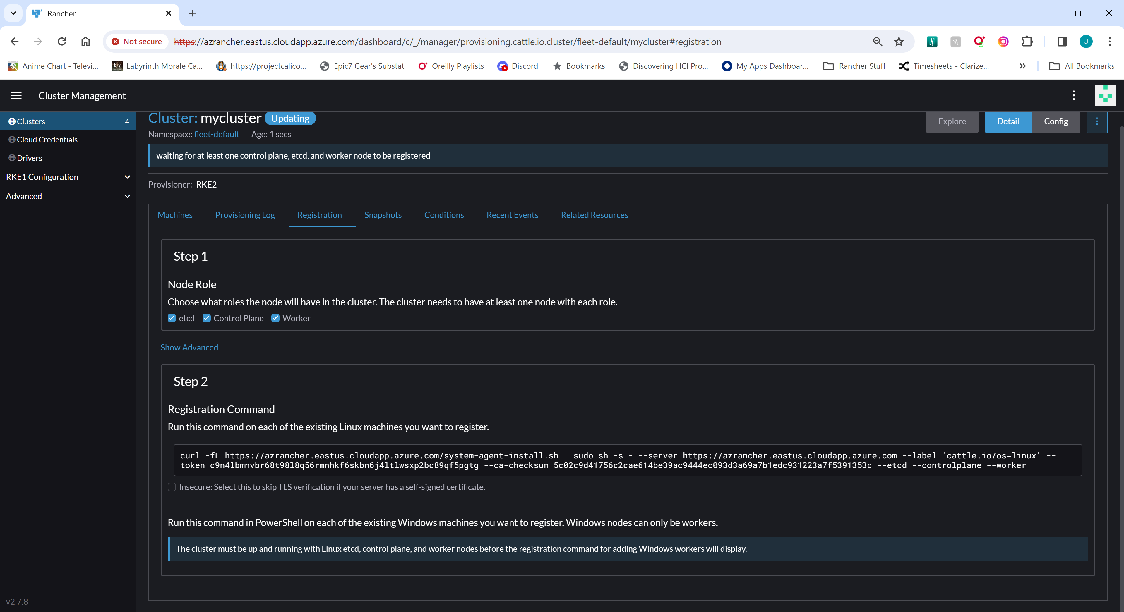

## Custom Cluster Registration from API calls

### Creating Cluster through Rancher CLI or by API call documentation

https://www.suse.com/support/kb/doc/?id=000020121

### Example for getting custom cluster registration command:

* Rancher URI = rancher.mycompany.com

* Downstream Cluster name = downstream001

### Get Cluster ID (returns rancher generated clusterid c-m-shw7c57m)

curl --insecure https://rancher.mycompany.com/v3/clusters?name=downstream001 -H 'content-type: application/json' -H "Authorization: Bearer token-hq8pw:9fkjfz85qfl7cxhzzm2d5jqbgf6x4fk4ng5md9g9msk6vtdgmws9bs" --insecure |jq -r .data[].id

### Get Cluster Registration Curl Commands

The following commands will return the curl command needed for joining base OS images to the

downstream cluster. Alternatives to these commands would be nodeCommand and

windowsNodeCommand to remove the "--insecure" from the returned curl command...

#### Controlplane, Etcd

curl --insecure https://rancher.mycompany.com/v3/clusters/c-m-shw7c57m/clusterregistrationtokens -H 'content-type: application/json' -H "Authorization: Bearer token-hq8pw:9fkjfz85qfl7cxhzzm2d5jqbgf6x4fk4ng5md9g9msk6vtdgmws9bs" --insecure |jq -r '.data[] |select(.name |contains("crt-")) | .insecureNodeCommand + " --controlplane --etcd"'

#### Controlplane, Etcd, and Worker

curl --insecure https://rancher.mycompany.com/v3/clusters/c-m-shw7c57m/clusterregistrationtokens -H 'content-type: application/json' -H "Authorization: Bearer token-hq8pw:9fkjfz85qfl7cxhzzm2d5jqbgf6x4fk4ng5md9g9msk6vtdgmws9bs" --insecure |jq -r '.data[] |select(.name |contains("crt-")) | .insecureNodeCommand + " --controlplane --etcd --worker"'

#### Worker Only

curl --insecure https://rancher.mycompany.com/v3/clusters/c-m-shw7c57m/clusterregistrationtokens -H 'content-type: application/json' -H "Authorization: Bearer token-hq8pw:9fkjfz85qfl7cxhzzm2d5jqbgf6x4fk4ng5md9g9msk6vtdgmws9bs" --insecure |jq -r '.data[] |select(.name |contains("crt-")) | .insecureNodeCommand + " --worker"'

#### Windows Node

curl --insecure https://rancher.mycompany.com/v3/clusters/c-m-shw7c57m/clusterregistrationtokens -H 'content-type: application/json' -H "Authorization: Bearer token-hq8pw:9fkjfz85qfl7cxhzzm2d5jqbgf6x4fk4ng5md9g9msk6vtdgmws9bs" --insecure |jq -r '.data[] |select(.name |contains("crt-")) | .insecureWindowsNodeCommand

### Example Output:

[root@rancher01 ~]#  curl --insecure https://rancher.mycompany.com/v3/clusters?name=downstream001 -H 'content-type: application/json' -H "Authorization: Bearer token-hq8pw:9fkjfz85qfl7cxhzzm2d5jqbgf6x4fk4ng5md9g9msk6vtdgmws9bs" --insecure |jq -r .data[].id

  % Total    % Received % Xferd  Average Speed   Time    Time     Time  Current

                                 Dload  Upload   Total   Spent    Left  Speed

100 15538    0 15538    0     0   176k      0 --:--:-- --:--:-- --:--:--  174k

c-m-shw7c57m

[root@rancher01 ~]# curl --insecure https://rancher.mycompany.com/v3/clusters/c-m-shw7c57m/clusterregistrationtokens -H 'content-type: application/json' -H "Authorization: Bearer token-hq8pw:9fkjfz85qfl7cxhzzm2d5jqbgf6x4fk4ng5md9g9msk6vtdgmws9bs" --insecure |jq -r '.data[] |select(.name |contains("crt-")) | .insecureNodeCommand + " --controlplane --etcd"'

  % Total    % Received % Xferd  Average Speed   Time    Time     Time  Current

                                 Dload  Upload   Total   Spent    Left  Speed

100 10861    0 10861    0     0  95271      0 --:--:-- --:--:-- --:--:-- 94443

 curl --insecure -fL https://rancher.mycompany.com/system-agent-install.sh | sudo  sh -s - --server https://rancher.mycompany.com --label 'cattle.io/os=linux' --token 5q2499v9xlqfhvsjrblkzw2dnq5kz5275h54gsb5nnfc665cv2kvtt --ca-checksum 5c02c9d41756c2cae614be39ac9444ec093d3a69a7b1edc931223a7f5391353c --controlplane --etcd

[root@rancher01 ~]# curl --insecure https://rancher.mycompany.com/v3/clusters/c-m-shw7c57m/clusterregistrationtokens -H 'content-type: application/json' -H "Authorization: Bearer token-hq8pw:9fkjfz85qfl7cxhzzm2d5jqbgf6x4fk4ng5md9g9msk6vtdgmws9bs" --insecure |jq -r '.data[] |select(.name |contains("crt-")) | .insecureNodeCommand + " --control-plane --etcd --worker"'

  % Total    % Received % Xferd  Average Speed   Time    Time     Time  Current

                                 Dload  Upload   Total   Spent    Left  Speed

100 10861    0 10861    0     0   134k      0 --:--:-- --:--:-- --:--:--  135k

 curl --insecure -fL https://rancher.mycompany.com/system-agent-install.sh | sudo  sh -s - --server https://rancher.mycompany.com --label 'cattle.io/os=linux' --token 5q2499v9xlqfhvsjrblkzw2dnq5kz5275h54gsb5nnfc665cv2kvtt --ca-checksum 5c02c9d41756c2cae614be39ac9444ec093d3a69a7b1edc931223a7f5391353c --control-plane --etcd --worker

[root@rancher01 ~]# curl --insecure https://rancher.mycompany.com/v3/clusters/c-m-shw7c57m/clusterregistrationtokens -H 'content-type: application/json' -H "Authorization: Bearer token-hq8pw:9fkjfz85qfl7cxhzzm2d5jqbgf6x4fk4ng5md9g9msk6vtdgmws9bs" --insecure |jq -r '.data[] |select(.name |contains("crt-")) | .insecureNodeCommand + " --worker"'

  % Total    % Received % Xferd  Average Speed   Time    Time     Time  Current

                                 Dload  Upload   Total   Spent    Left  Speed

100 10861    0 10861    0     0   173k      0 --:--:-- --:--:-- --:--:--  173k

 curl --insecure -fL https://rancher.mycompany.com/system-agent-install.sh | sudo  sh -s - --server https://rancher.mycompany.com --label 'cattle.io/os=linux' --token 5q2499v9xlqfhvsjrblkzw2dnq5kz5275h54gsb5nnfc665cv2kvtt --ca-checksum 5c02c9d41756c2cae614be39ac9444ec093d3a69a7b1edc931223a7f5391353c --worker

[root@rancher01 ~]# curl --insecure https://rancher.mycompany.com/v3/clusters/c-m-shw7c57m/clusterregistrationtokens -H 'content-type: application/json' -H "Authorization: Bearer token-hq8pw:9fkjfz85qfl7cxhzzm2d5jqbgf6x4fk4ng5md9g9msk6vtdgmws9bs" --insecure |jq -r '.data[] |select(.name |contains("crt-")) | .insecureWindowsNodeCommand'

  % Total    % Received % Xferd  Average Speed   Time    Time     Time  Current

                                 Dload  Upload   Total   Spent    Left  Speed

100 10861    0 10861    0     0   165k      0 --:--:-- --:--:-- --:--:--  165k

 curl.exe --insecure -fL https://rancher.mycompany.com/wins-agent-install.ps1 -o install.ps1; Set-ExecutionPolicy Bypass -Scope Process -Force; ./install.ps1 -Server https://rancher.mycompany.com -Label 'cattle.io/os=windows' -Token 5q2499v9xlqfhvsjrblkzw2dnq5kz5275h54gsb5nnfc665cv2kvtt -Worker -CaChecksum 5c02c9d41756c2cae614be39ac9444ec093d3a69a7b1edc931223a7f5391353c

# Longhorn Backup To MINIO

REF: <https://oopflow.medium.com/how-to-backup-longhorn-to-minio-s3-9c8c126ae92e>

## Longhorn MINIO Setup

### Create Minio Bucket

Example: daily-longhorn-backup

### Create Access Key and Secret Key

### In Minio settings

Set a Region to onprep-sp

Set Description for Region

### Recorded Information So Far

Bucket Name: daily-longhorn-backup

Url: http://minio.mycompany.com:9000/

AccessKey: <FROM_MINIO_UI>

SecretKey: <FROM_MINIO_UI>

Region: us-east-01

### Encode information for use in creating secret

echo -n http://minio.mycompany.com:9000/ |base64

echo -n ACCESSKEY |base64

echo -n SECRETKEY |base64

### Create Secret longhorn-minio-credential.yaml

apiVersion: v1

kind: Secret

metadata:

  name: longhorn-minio-credentials

  namespace: longhorn-system

type: Opaque

data:

  AWS_ACCESS_KEY_ID: BASE64_OF_ACCESSKEY

  AWS_SECRET_ACCESS_KEY: BASE64_OF_SECRETKEY

  AWS_ENDPOINTS: BASE64_OF_URL

### Apply secret

kubectl apply -f longhorn-minio-credentials.yaml

### Configure Longhorn for Backups

#### In Longhorn Settings (General Settings Page) scroll down to Backup Target

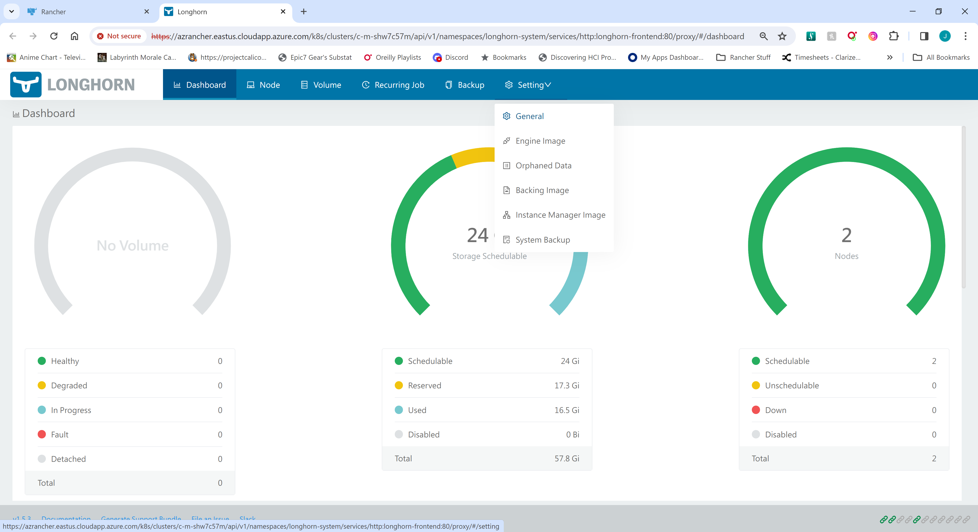

#### Modify the Backup Target and Credential

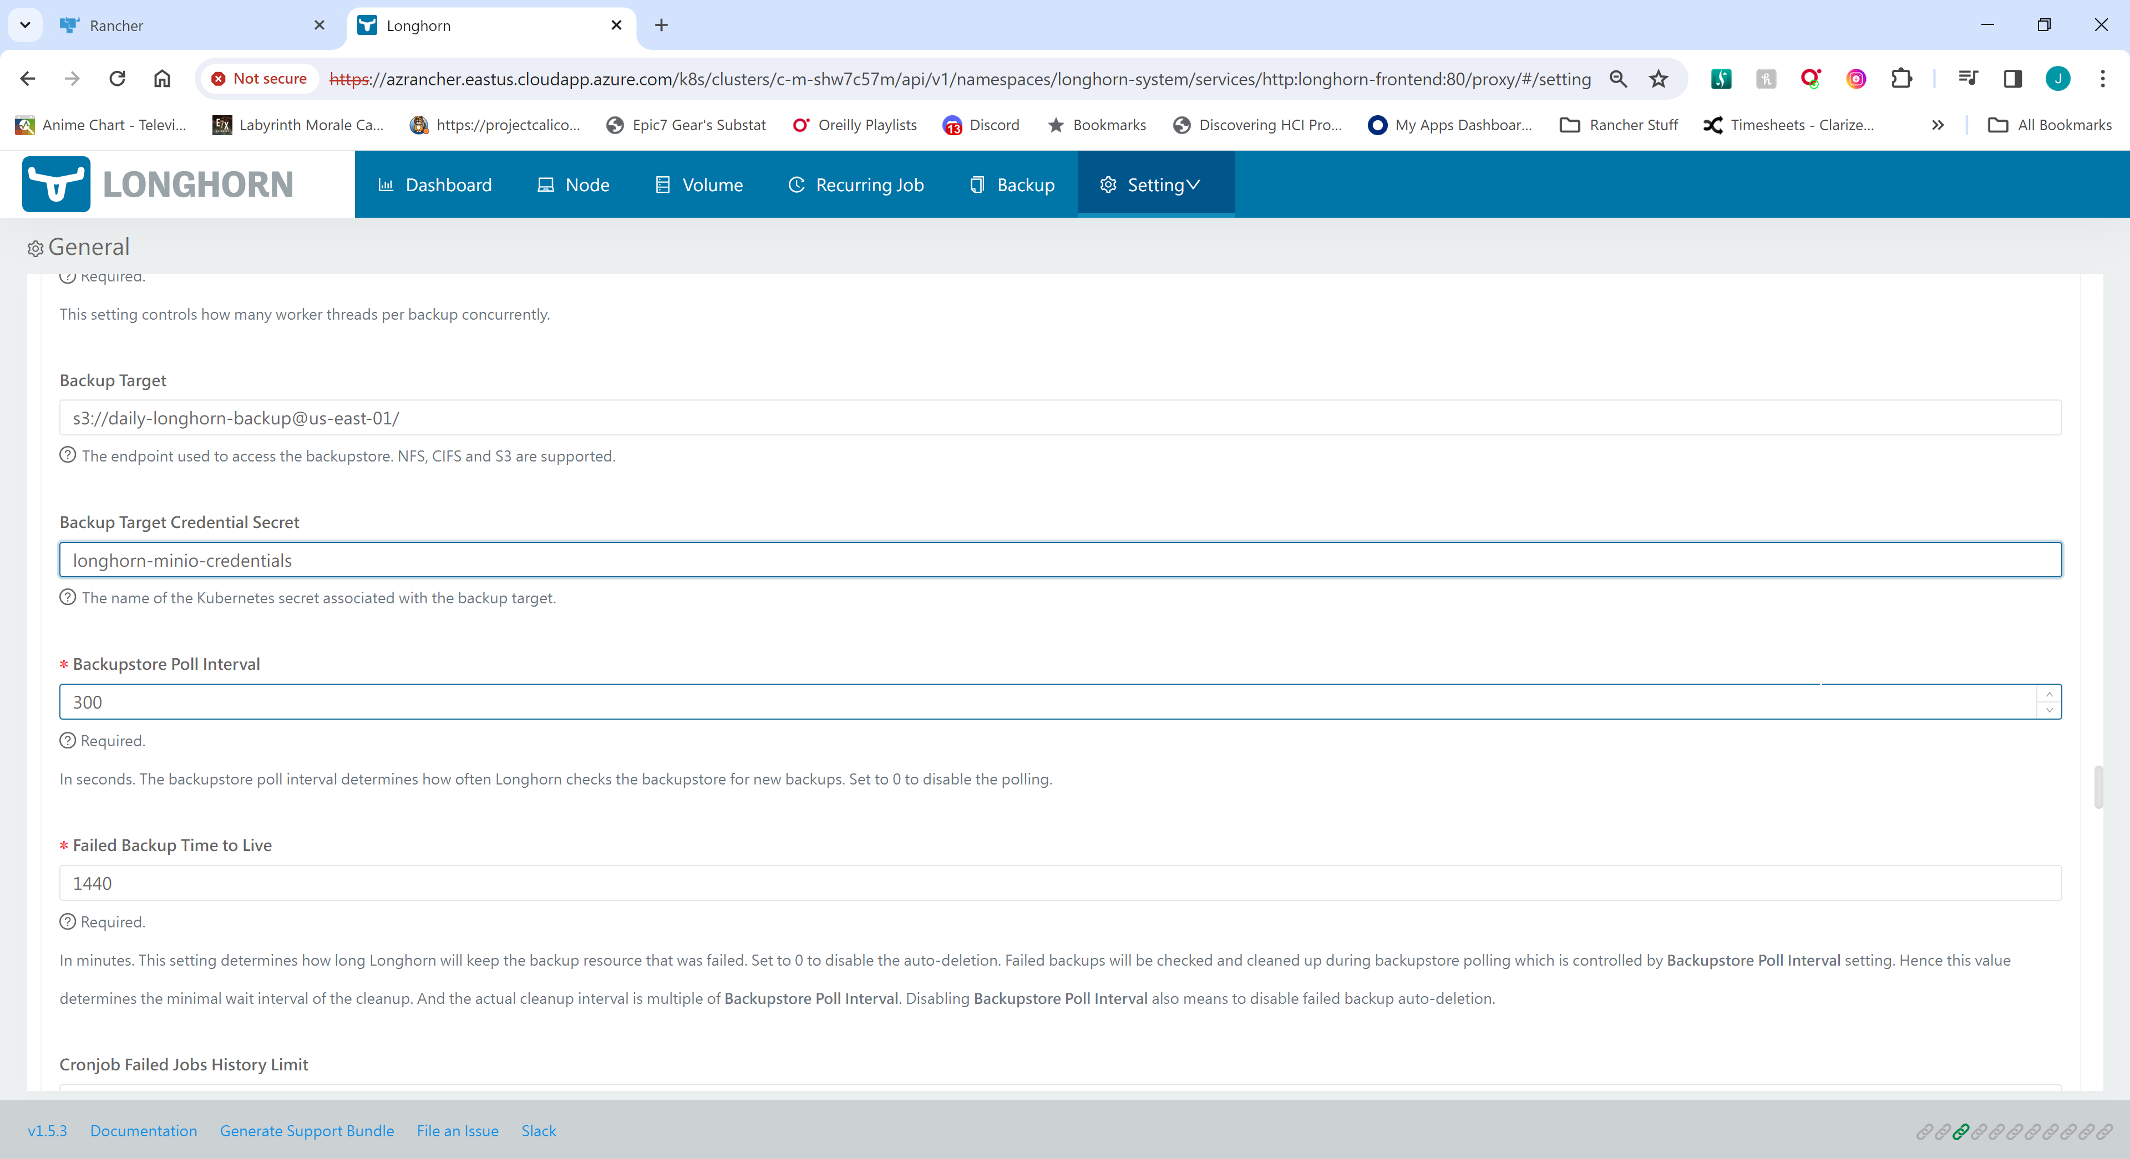

Backup Target

s3://daily-longhorn-backup@us-east-01/

Backup Target Credential

longhorn-minio-credentials

# Harbor Installation via HELM

REF: <https://github.com/goharbor/harbor-helm/blob/main/values.yaml>

Rancher Values line numbers do not match the values.yaml in the helm chart in the Rancher GUI.

Line numbers below are approximate.

## Install Harbor from Rancher Partner Charts

### Create Namespace for Harbor Installation

Create namespace in the gui or with the following kubectl command

kubectl create namespace harbor

### From Rancher UI Navigate to Apps 🡪 Charts

Select Partner Charts From the Pulldown and Filter by Harbor as shown below

Click on Harbor Chart to initiate installation

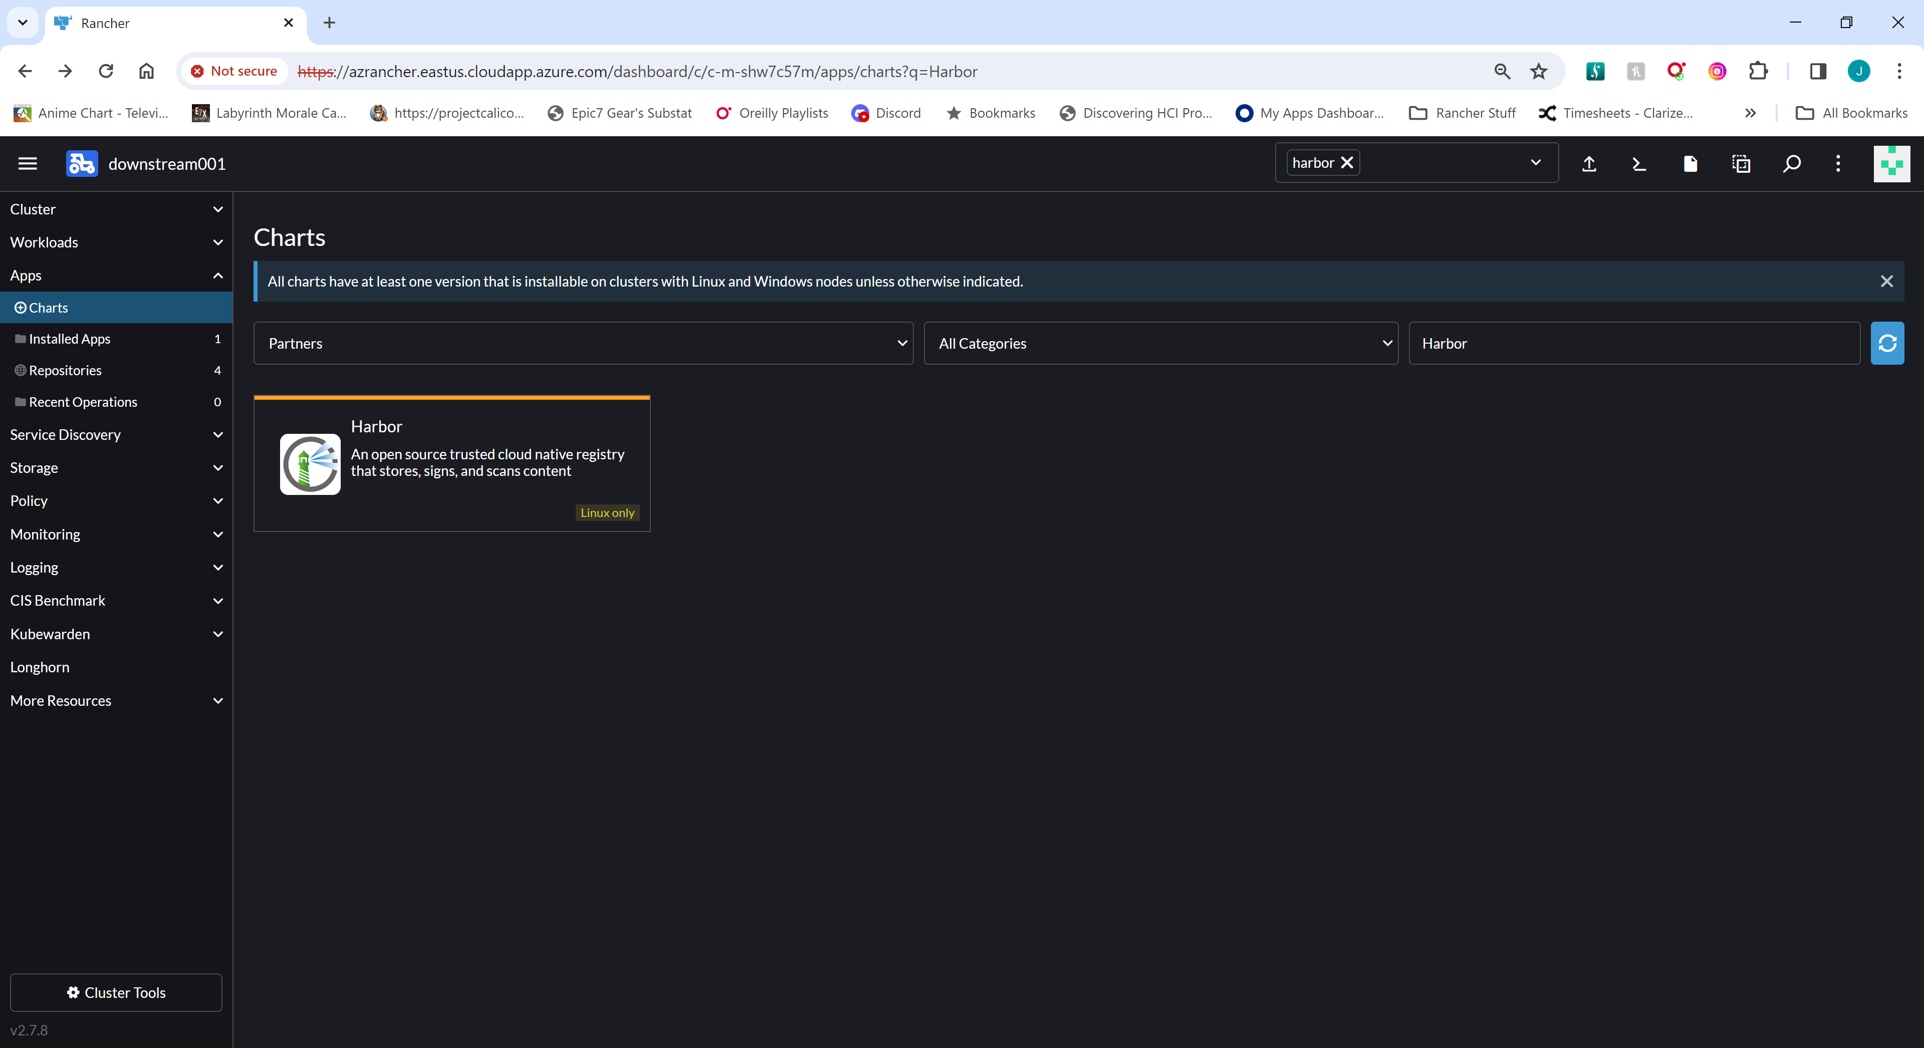

### Click Install

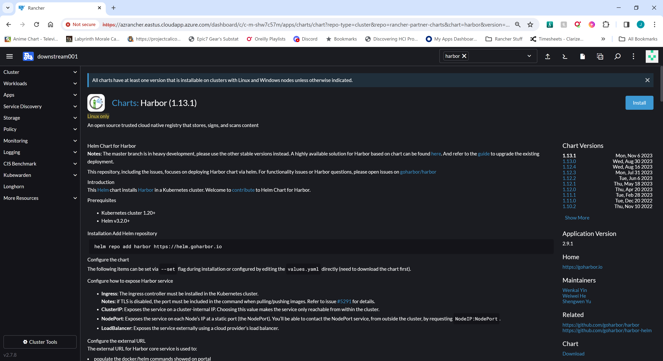

### Enter namespace and deployment name for harbor and click Next

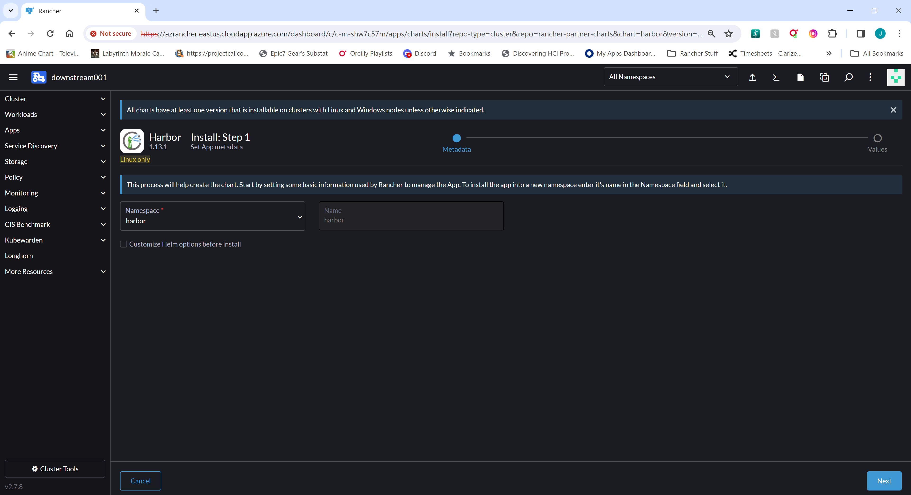

## Modify Harber Values

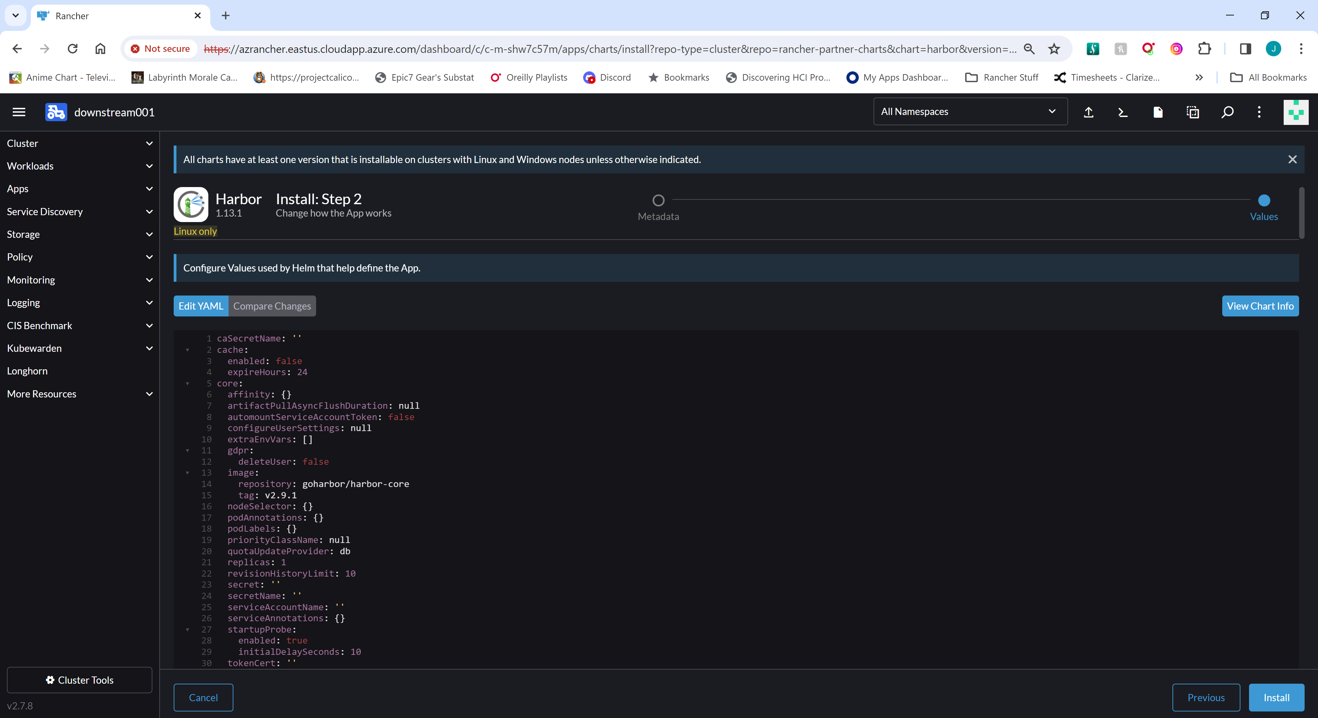

### Customize helm values for installation.

Lines ~128-134 (Optional)

Setup TLS cert info.

Provide secret name that contains the tls.key and tls.crt the harbor URL

If providing your own cert/secret, set line 134 “certSource: secret”

If left blank, will create a secret and cert pair via certmanager called "harbor-ingress"

Can be changed manually later by updating the ingress to use a different secret.

Line ~109 & ~136 (Required)

Set the URL for the harbor core instance.

Line ~137 (Optional)

Default Harbor12345

Recommended to change this either during install or through Harbor UI

Line ~264 persistentVolumeClaim (Optional/Recommended)

Sets the sizing for the PVC's that will get created by the chart. If the storageClass for a

particular PVC is not set implicitly, the default storage class (in this case longhorn) will

be used to create the appropriate PV's.

Set appropriate sizes for PV’s

### Consider changing passwords

Any default passwords for the DB/redis/etc should be changed at INSTALL

Line ~57: Internal Postgres password

Line ~364: registry password

Line ~396: secretKey set to "not-a-secure-key"

### Update Node Selectors

Note: Line numbers will shift as you add Node Selectors

Line 16 – Core 🡪 zone: infra

Line 57 – Database 🡪 storage: data

Line 83 – Exporter 🡪 zone: infra

Line 184 – Job Service 🡪 zone: infra

Line 229 – nginx 🡪 zone: infra

Line 314 – portal 🡪 zone: infra

Line 351 – redis 🡪zone: infra

Line 382 – registry 🡪 zone: infra

Line 429 – Trivy 🡪 zone: infra

### Other lines of interest

Lines ~236-263

Possibly be able to setup image storage outside of Kubernetes or to MINIO instance.

Defaults to "filesystem" which I will assume means to a PV that is setup for the instance.

### See Appendix A for example values file

## Perform Install

### Click Install once all edits have been made to the values



# Neuvector Installation

## Create the neuvector project

To create a new project, click the Create Project button on the top right corner.

Project: Create page will be displayed.

For the project Name, enter:

neuvector

Click the Create button on the bottom right corner.

The new project will be available in the bottom of the list displayed.

## Install Nuevector from Cluster Tools

From the bottom left corner, click the Cluster Tools button.

From the list of applications, locate NeuVector.

Click the Install button.

An Install: Step 1 form will be displayed.

Feel free to read the information provided for the NeuVector Helm chart.

For the Install into Project dropdown menu, select neuvector.

From the bottom right, click the Next button.

From the form menu items on the left, click the Container Runtime link.

Container Runtime information will be displayed.

Deselect Docker Runtime.

Select k3s Containerd Runtime.

Verify the Runtime Path is /run/k3s/containerd/containerd.sock

From the form menu items on the left, click PVC Configuration.

Enter/select the following information:

PVC Status: (selected)

Storage Class Name: longhorn

From the form menu items on the left, click Service Configuration.

From the Manager Service Type dropdown menu, select ClusterIP.

To launch the SUSE NeuVector deployment, click the Install button on the bottom right.

A chart deployment tab will be opened in the bottom part of the browser

window. It will take a couple of minutes for the deployment to complete.

Close the deployment tab.

Ref: <https://www.youtube.com/watch?v=jgkgEpel_98>

# Rolling Restart Procedure

## Restart Rancher Management Cluster

### Control-Plane

Restart one node at a time

Graceful shutdown and reboot of a node should accomplish a clean shutdown of RKE2

For situations when a reboot is not necessary, can restart from the command line:

systemctl restart rke2-server

## Restart Downstream Cluster

### Control-Plane

Restart control-planes one node at a time

Graceful shutdown and reboot of a node should accomplish a clean shutdown of RKE2

For situations when a reboot is not necessary, can restart from the command line:

systemctl restart rke2-server

### Worker

Restart one node at a time

Graceful shutdown and reboot of a node should accomplish a clean shutdown of RKE2

For situations when a reboot is not necessary, can restart from the command line:

systemctl restart rke2-agent

# Shutdown and Startup

Perform the following tasks on all Downstream clusters first. Then perform the ControlPlane tasks for the Rancher Management Server nodes.

## Shutdown

### Shutdown Worker Nodes

ssh into the worker node

stop rke2-agent

systemctl stop rke2-agent

shutdown the system

shutdown now

### Shutdown ControlPlane Nodes One At A Time

ssh into the controlplane node

stop rke2-server

systemctl stop rke2-server

shutdown the system

shutdown now

## Startup

### Startup ControlPlane Nodes One At A Time

Power on the system

ssh into the controlplane node

check status of rke2-server

systemctl status rke2-server

### Startup Worker Nodes

Power on the system

ssh into the worker node

check status of rke2-agent

systemctl status rke2-agent

# Rancher App Charts

## Rancher provided Helm Charts

Rancher provides a number of application charts as well as Partner charts for useful applications. Some applications are only visible on the Rancher local cluster, while other utilities such as Longhorn and Logging are available for installation on downstream clusters as well.

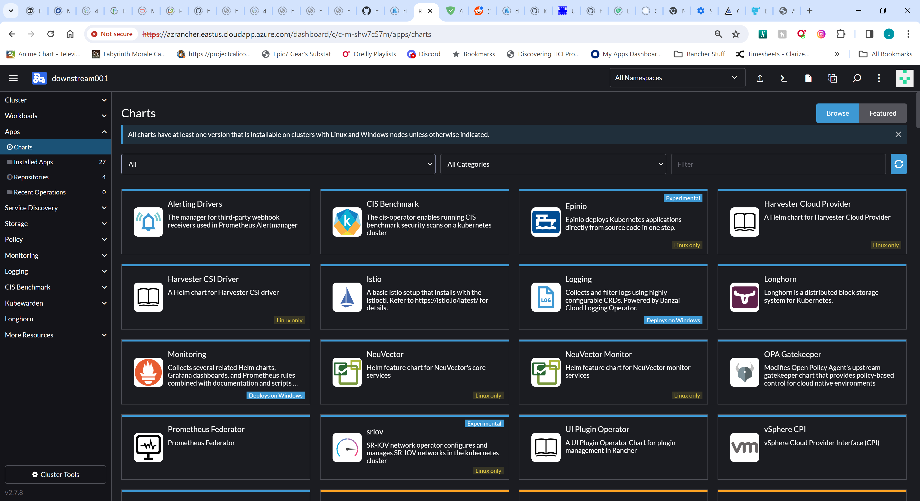

## Recommended Tools

1. Longhorn (Opensource with paid support option)
2. Nuevector (Opensource with paid support option)
3. CIS Benchmark
4. Alerting Drivers
5. Logging
6. Monitoring
7. Rancher Backup (local cluster only)

Descriptions of these tools as well as Partner applications can be found by selecting any of the Apps from Apps 🡪 Charts on both the local and downstream clusters.

# APPENDIX A – Harbor Values

caSecretName: ''

cache:

  enabled: false

  expireHours: 24

core:

  affinity: {}

  artifactPullAsyncFlushDuration: null

  automountServiceAccountToken: false

  configureUserSettings: null

  extraEnvVars: []

  gdpr:

    deleteUser: false

  image:

    repository: goharbor/harbor-core

    tag: v2.9.1

  nodeSelector:

    zone: infra

  podAnnotations: {}

  podLabels: {}

  priorityClassName: null

  quotaUpdateProvider: db

  replicas: 1

  revisionHistoryLimit: 10

  secret: ''

  secretName: ''

  serviceAccountName: ''

  serviceAnnotations: {}

  startupProbe:

    enabled: true

    initialDelaySeconds: 10

  tokenCert: ''

  tokenKey: ''

  tolerations: []

  topologySpreadConstraints: []

  xsrfKey: ''

database:

  external:

    coreDatabase: registry

    existingSecret: ''

    host: 192.168.0.1

    password: password

    port: '5432'

    sslmode: disable

    username: user

  internal:

    affinity: {}

    automountServiceAccountToken: false

    extraEnvVars: []

    image:

      repository: goharbor/harbor-db

      tag: v2.9.1

    initContainer:

      migrator: {}

      permissions: {}

    livenessProbe:

      timeoutSeconds: 1

    nodeSelector:

      storage: data

    password: HbR2024@SuSE

    priorityClassName: null

    readinessProbe:

      timeoutSeconds: 1

    serviceAccountName: ''

    shmSizeLimit: 512Mi

    tolerations: []

  maxIdleConns: 100

  maxOpenConns: 900

  podAnnotations: {}

  podLabels: {}

  type: internal

enableMigrateHelmHook: false

existingSecretAdminPasswordKey: HARBOR_ADMIN_PASSWORD

existingSecretSecretKey: ''

exporter:

  affinity: {}

  automountServiceAccountToken: false

  cacheCleanInterval: 14400

  cacheDuration: 23

  extraEnvVars: []

  image:

    repository: goharbor/harbor-exporter

    tag: v2.9.1

  nodeSelector:

    zone: infra

  podAnnotations: {}

  podLabels: {}

  priorityClassName: null

  replicas: 1

  revisionHistoryLimit: 10

  serviceAccountName: ''

  tolerations: []

  topologySpreadConstraints: []

expose:

  clusterIP:

    annotations: {}

    name: harbor

    ports:

      httpPort: 80

      httpsPort: 443

  ingress:

    annotations:

      ingress.kubernetes.io/proxy-body-size: '0'

      ingress.kubernetes.io/ssl-redirect: 'true'

      nginx.ingress.kubernetes.io/proxy-body-size: '0'

      nginx.ingress.kubernetes.io/ssl-redirect: 'true'

    className: ''

    controller: default

    harbor:

      annotations: {}

      labels: {}

    hosts:

      core: harbor.mycompany.com

    kubeVersionOverride: ''

  loadBalancer:

    IP: ''

    annotations: {}

    name: harbor

    ports:

      httpPort: 80

      httpsPort: 443

    sourceRanges: []

  nodePort:

    name: harbor

    ports:

      http:

        nodePort: 30002

        port: 80

      https:

        nodePort: 30003

        port: 443

  tls:

    auto:

      commonName: ''

    certSource: secret

    enabled: true

    secret:

      secretName: 'harbor-cert-secret'

  type: ingress

externalURL: https://harbor.mycompany.com

harborAdminPassword: Harbor12345

imagePullPolicy: IfNotPresent

imagePullSecrets: null

internalTLS:

  certSource: auto

  core:

    crt: ''

    key: ''

    secretName: ''

  enabled: false

  jobservice:

    crt: ''

    key: ''

    secretName: ''

  portal:

    crt: ''

    key: ''

    secretName: ''

  registry:

    crt: ''

    key: ''

    secretName: ''

  strong_ssl_ciphers: false

  trivy:

    crt: ''

    key: ''

    secretName: ''

  trustCa: ''

ipFamily:

  ipv4:

    enabled: true

  ipv6:

    enabled: true

jobservice:

  affinity: {}

  automountServiceAccountToken: false

  extraEnvVars: []

  image:

    repository: goharbor/harbor-jobservice

    tag: v2.9.1

  jobLoggers:

    - file

  loggerSweeperDuration: 14

  maxJobWorkers: 10

  nodeSelector:

    zone: infra

  notification:

    webhook_job_http_client_timeout: 3

    webhook_job_max_retry: 3

  podAnnotations: {}

  podLabels: {}

  priorityClassName: null

  reaper:

    max_dangling_hours: 168

    max_update_hours: 24

  replicas: 1

  revisionHistoryLimit: 10

  secret: ''

  serviceAccountName: ''

  tolerations: []

  topologySpreadConstraints: null

logLevel: info

metrics:

  core:

    path: /metrics

    port: 8001

  enabled: false

  exporter:

    path: /metrics

    port: 8001

  jobservice:

    path: /metrics

    port: 8001

  registry:

    path: /metrics

    port: 8001

  serviceMonitor:

    additionalLabels: {}

    enabled: false

    interval: ''

    metricRelabelings: []

    relabelings: []

nginx:

  affinity: {}

  automountServiceAccountToken: false

  extraEnvVars: []

  image:

    repository: goharbor/nginx-photon

    tag: v2.9.1

  nodeSelector:

    zone: infra

  podAnnotations: {}

  podLabels: {}

  priorityClassName: null

  replicas: 1

  revisionHistoryLimit: 10

  serviceAccountName: ''

  tolerations: []

  topologySpreadConstraints: []

persistence:

  enabled: true

  imageChartStorage:

    azure:

      accountkey: base64encodedaccountkey

      accountname: accountname

      container: containername

      existingSecret: ''

    disableredirect: false

    filesystem:

      rootdirectory: /storage

    gcs:

      bucket: bucketname

      encodedkey: base64-encoded-json-key-file

      existingSecret: ''

      useWorkloadIdentity: false

    oss:

      accesskeyid: accesskeyid

      accesskeysecret: accesskeysecret

      bucket: bucketname

      region: regionname

    s3:

      bucket: bucketname

      region: us-west-1

    swift:

      authurl: https://storage.myprovider.com/v3/auth

      container: containername

      password: password

      username: username

    type: filesystem

  persistentVolumeClaim:

    database:

      accessMode: ReadWriteOnce

      annotations: {}

      existingClaim: ''

      size: 10Gi

      storageClass: ''

      subPath: ''

    jobservice:

      jobLog:

        accessMode: ReadWriteOnce

        annotations: {}

        existingClaim: ''

        size: 1Gi

        storageClass: ''

        subPath: ''

    redis:

      accessMode: ReadWriteOnce

      annotations: {}

      existingClaim: ''

      size: 1Gi

      storageClass: ''

      subPath: ''

    registry:

      accessMode: ReadWriteOnce

      annotations: {}

      existingClaim: ''

      size: 200Gi

      storageClass: ''

      subPath: ''

    trivy:

      accessMode: ReadWriteOnce

      annotations: {}

      existingClaim: ''

      size: 5Gi

      storageClass: ''

      subPath: ''

  resourcePolicy: keep

portal:

  affinity: {}

  automountServiceAccountToken: false

  extraEnvVars: []

  image:

    repository: goharbor/harbor-portal

    tag: v2.9.1

  nodeSelector:

    zone: infra

  podAnnotations: {}

  podLabels: {}

  priorityClassName: null

  replicas: 1

  revisionHistoryLimit: 10

  serviceAccountName: ''

  tolerations: []

  topologySpreadConstraints: []

proxy:

  components:

    - core

    - jobservice

    - trivy

  httpProxy: null

  httpsProxy: null

  noProxy: 127.0.0.1,localhost,.local,.internal

redis:

  external:

    addr: 192.168.0.2:6379

    coreDatabaseIndex: '0'

    existingSecret: ''

    jobserviceDatabaseIndex: '1'

    password: ''

    registryDatabaseIndex: '2'

    sentinelMasterSet: ''

    trivyAdapterIndex: '5'

    username: ''

  internal:

    affinity: {}

    automountServiceAccountToken: false

    extraEnvVars: []

    image:

      repository: goharbor/redis-photon

      tag: v2.9.1

    jobserviceDatabaseIndex: '1'

    nodeSelector:

      zone: infra

    priorityClassName: null

    registryDatabaseIndex: '2'

    serviceAccountName: ''

    tolerations: []

    trivyAdapterIndex: '5'

  podAnnotations: {}

  podLabels: {}

  type: internal

registry:

  affinity: {}

  automountServiceAccountToken: false

  controller:

    extraEnvVars: []

    image:

      repository: goharbor/harbor-registryctl

      tag: v2.9.1

  credentials:

    existingSecret: ''

    password: HbR2024@SuSE

    username: harbor_registry_user

  middleware:

    cloudFront:

      baseurl: example.cloudfront.net

      duration: 3000s

      ipfilteredby: none

      keypairid: KEYPAIRID

      privateKeySecret: my-secret

    enabled: false

    type: cloudFront

  nodeSelector:

    zone: infra

  podAnnotations: {}

  podLabels: {}

  priorityClassName: null

  registry:

    extraEnvVars: []

    image:

      repository: goharbor/registry-photon

      tag: v2.9.1

  relativeurls: false

  replicas: 1

  revisionHistoryLimit: 10

  secret: ''

  serviceAccountName: ''

  tolerations: []

  topologySpreadConstraints: []

  upload_purging:

    age: 168h

    dryrun: false

    enabled: true

    interval: 24h

secretKey: HbR2024@SuSE

trace:

  enabled: false

  jaeger:

    endpoint: http://hostname:14268/api/traces

  otel:

    compression: false

    endpoint: hostname:4318

    insecure: true

    timeout: 10

    url_path: /v1/traces

  provider: jaeger

  sample_rate: 1

trivy:

  affinity: {}

  automountServiceAccountToken: false

  debugMode: false

  enabled: true

  extraEnvVars: []

  gitHubToken: ''

  ignoreUnfixed: false

  image:

    repository: goharbor/trivy-adapter-photon

    tag: v2.9.1

  insecure: false

  nodeSelector:

    zone: infra

  offlineScan: false

  podAnnotations: {}

  podLabels: {}

  priorityClassName: null

  replicas: 1

  resources:

    limits:

      cpu: 1

      memory: 1Gi

    requests:

      cpu: 200m

      memory: 512Mi

  securityCheck: vuln

  serviceAccountName: ''

  severity: UNKNOWN,LOW,MEDIUM,HIGH,CRITICAL

  skipUpdate: false

  timeout: 5m0s

  tolerations: []

  topologySpreadConstraints: []

  vulnType: os,library

updateStrategy:

  type: RollingUpdate

# Appendix B - Logging Configs

Secrets used for authentication need to be created manually.  
Additional configuration information can be found here:  
<https://kube-logging.dev/docs/configuration/>  
or  
[Rancher Documentation - Flows and Cluster Flows](https://ranchermanager.docs.rancher.com/integrations-in-rancher/logging/custom-resource-configuration/flows-and-clusterflows)

## ClusterFlow (Active – Cluster scope)

apiVersion: logging.banzaicloud.io/v1beta1

kind: ClusterFlow

metadata:

name: opensearch-fluentd-flow

  namespace: cattle-logging-system

spec:

  globalOutputRefs:

    - opensearch-fluentd

## ClusterOutput (Active – Cluster Scope)

apiVersion: logging.banzaicloud.io/v1beta1

kind: ClusterOutput

metadata:

  name: opensearch-fluentd

  namespace: cattle-logging-system

spec:

  opensearch:

    host: 192.18.21.159

    index_name: rancher-logs

    password:

      valueFrom:

        secretKeyRef:

          key: user

          name: opensearch-fluentd-password

    port: 9200

    scheme: https

    ssl_verify: false

    suppress_type_name: true

    user: admin

## Flow (Example – Namespace Scope)

apiVersion: logging.banzaicloud.io/v1beta1

kind: Flow

metadata:

  name: nginx-fluentd-flow

  namespace: flow-example

spec:

  localOutputRefs:

    - nginx-fluentd-output

  match:

    - select:

## Output (Example – Namespace Scope)

apiVersion: logging.banzaicloud.io/v1beta1

kind: Output

metadata:

  name: nginx-fluentd-output

  namespace: flow-example

spec:

  opensearch:

    host: 192.18.21.159

    index_name: nginx-logs

    password:

      valueFrom:

        secretKeyRef:

          key: user

          name: nginx-opensearch-fluentd-password

    port: 9200

    scheme: https

    ssl_verify: false

    suppress_type_name: true

    user: admin

# Appendix C – Training and References

## Rancher Documentation

**Description**: Official documentation for Rancher

<https://ranchermanager.docs.rancher.com/>

## RKE2 Documentation

**Description**: Official documentation for RKE2

<https://docs.rke2.io/>

## Harvester Documentation

**Description**: Official documentation for Harvester

<https://docs.harvesterhci.io>

## Longhorn Documentation

**Description**: Official documentation for Longhorn

<https://longhorn.io/docs>

## Neuvector Documentation

**Description**: Official documentation for Neuvector

<https://open-docs.neuvector.com/>

## Suse Events

**Description**: Free Online Events, Training and Webinars from SuSE on Rancher, Neuvector, etc.

<https://www.suse.com/events/>

## Rancher Academy

**Description**: Collection of FREE Rancher, RKE2, and Kubernetes related training

<https://www.rancher.academy/collections>

## Neuvector Youtube

**Description**: Official Youtube for Neuvector and Neuvector 101 video that goes over basic

capabilities and configuration of Neuvector

<https://www.youtube.com/@NeuVector/>

<https://www.youtube.com/watch?v=9ihaBr_QGzQ>

## Rancher Github

**Description**: Github repository for the latest releases of Rancher. Submit bug reports, research

upgrades, etc

<https://github.com/rancher/rancher/>

## RKE2 Github

**Description**: Github repository with the latest releases of RKE2. Cross reference with Rancher

Github releases to insure compatibility with Rancher. Submit bug reports, research upgrades, etc

<https://github.com/rancher/rke2/>

## Neuvector Github

**Description**: Git hub repository with the latest release of Neuvector. Submit bug reports,

research upgrades, etc

<https://github.com/neuvector/neuvector>

## Longhorn Github

**Description**: Github repository with the latest releases of Longhorn. Submit bug reports, research

upgrades, etc

<https://github.com/longhorn/longhorn>

## Harvester Github

**Description**: Github repository with the latest release of Harvester. Submit bug reports,

research upgrades, etc

<https://github.com/harvester/harvester>

## CIS Self Assessment

**Description**: CIS Self Assessment ling for CIS 1.6 and CIS 1.23 from RKE2 Documentation

Can be used to verify Compliance in Neuvector as well for Kubernetes as the sections should map

correctly to the Kubernetes category. For example CIS 1.6 section 1.2.10 directly maps to K.1.2.10

in Neuvector Compliance.

<https://docs.rke2.io/security/cis_self_assessment16>

<https://docs.rke2.io/security/cis_self_assessment123>